Promote and invite NEW Vocations

WHAT CAN
I
DO?

POSTER PRESENTATION

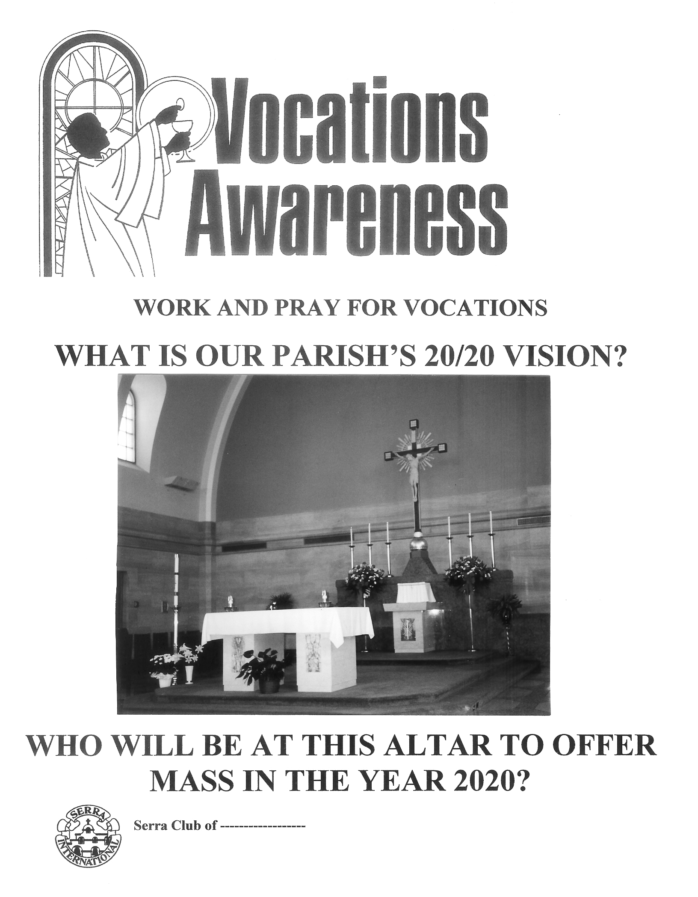

It's okay to volunteer to take a vocations poster from your club or diocese to a pastor and ask if you can put it up in his parish.
- - - - - - - - - -

Posters available from USAC;
all you need to do is attach
a picture of a parish’s altar
in the designated space.

- - - - - - - - - -

THIS SPRING – arrange with your pastor to call attention to the poster from the pulpit and in the weekly bulletin.

