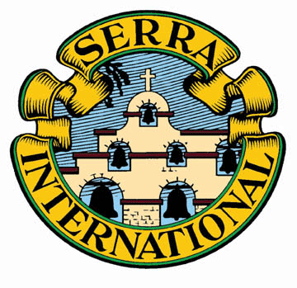 United States Council of Serra International Membership Recruitment Team

Acceptance of Mentoring
Date: ____________
Dear District Governor ___________________
We accept your offer to mentor and encourage our club during our 2014 Fall Membership Campaign!
Our goal is an increase of ____% in new members by Thanksgiving.
We currently have ____ members in our Club.

Thank you!

Club Name: _________________________________________
Club Number: ______________
City, ST: _____________________________
President Name: _____________________________ President Phone: _____________
President email: _____________________________

*************************************************************************************
District Governor completes this section and forwards to Peter Cunningham: pcunningham@serraus.org

Region: ___ District: _____
DG Name: ___________________________________
DG Home Phone: _______________________
DG Cell Phone: _________________________
DG email: ____________________________________

Acceptance of Mentoring by Club Presidents, 8-10-14

