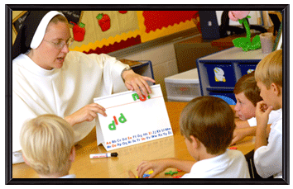

“Focus on NEW Vocations”

WHAT CAN
I
DO?

Do you know some young people
who want to be teachers?

Help them explore becoming a Religious teacher
i.e. Christian Brother Dominican Sister
Oblate Brother Notre Dame Sister
Benedictine Brother Marist Sisters
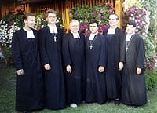

Good teachers of the Faith are always needed.

“The Gospel is not the exclusive prerogative of
those who received it, but a gift to be shared, a
piece of good news to be passed on. This gift of
commitment - is entrusted not just to the few, but
to all baptized people.” Pope Benedict the XVI

