
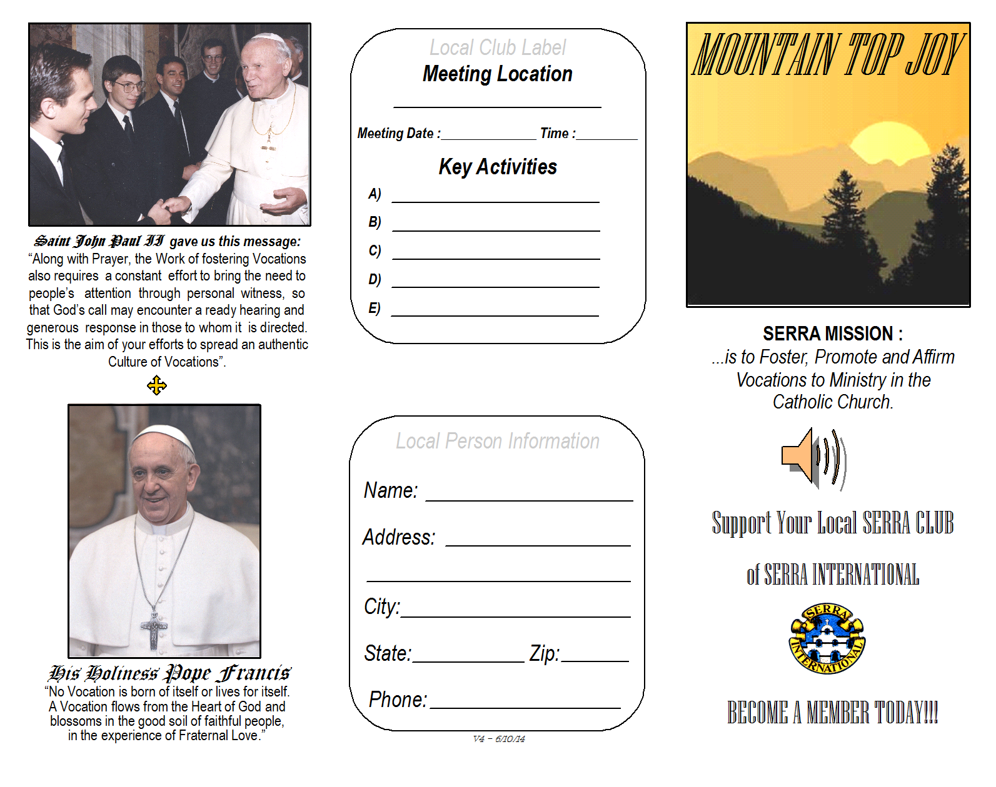
Add your local club information here:

Meeting Place:

Day/Time:

Club Activities/Calendar
For more information contact:

Name:

Address

Telephone:

Email:

